**POLICY OF GRAND WEST ESTATES OWNERS ASSOCIATION REGARDING POLICIES AND PROCEDURES FOR COVENANT AND RULE ENFORCEMENT**

**SUBJECT**:

**PURPOSE:**

**AUTHORITY:**

**EFFECTIVE DATE:**

Adoption of a policy regarding the enforcement of covenants and rules and procedures for the notice of alleged violations, conduct of hearings and imposition of fines.

To adopt a uniform procedure to be followed when enforcing covenants and rules to facilitate the efficient operation of the Association.

The Declaration, Articles of Incorporation and Bylaws of the Association, and Colorado law.

June 28, 2025

**RESOLUTION:** The Association hereby adopts the following procedures to be followed when enforcing the covenants and rules of the Association:

1. Reporting Violations. Complaints regarding alleged violations may be reported by an Owner or resident within the community, a group of Owners or residents, the Association’s management company, if any, Board member(s) or committee member(s) by submission of a written complaint.
2. Complaints. Complaints by Owners or residents, member of the Board of Directors, a committee member, or the manager shall be in writing and submitted to the Board of Directors. The complaining Owner or resident shall have observed the alleged violation and shall identify the complainant (“Complainant”), the alleged violator (“Violator”), if known, and set forth a statement describing the alleged violation, referencing the specific provisions which are alleged to have been violated, when the violation was observed and any other pertinent information. Non-written complaints or written complaints failing to include any information required by this provision may not be investigated or prosecuted at the discretion of the Association.
3. Investigation. Upon receipt of a complaint by the Association, if additional information is needed, the complaint may be returned to the Complainant or may be investigated further by a Board designated individual or committee. The Board shall have sole discretion in appointing an individual or committee to investigate the matter.
4. Violation Which Threatens Public Safety or Health. With respect to any violation of the Declaration, Bylaws, Covenants, or other Governing Documents of an Association that the Board of Directors reasonably determines threatens the public safety or health, the Association shall provide the Owner an initial letter (see Paragraph 7 below) of the violation informing the Owner that the Owner has seventy-two (72) hours to cure the violation or the Association may fine the Owner.
   1. If, after an inspection of the Lot, the Association determines that the Owner has not cured the violation within seventy-two (72) hours after receiving the notice, the Association may impose fines on the Owner every other day and may take legal action against the Owner for the violation.
   2. Violation Cured by Owner. Once the Association determines that an Owner has cured a violation, the Association shall notify the Owner, in English and in any other language that the Owner has indicated a preference for correspondence and notices pursuant to

C.R.S. 38-33.3-209.5 (1.7)(a)(I).

1. That the Owner will not be further fined with regard to the violation; and
2. Of any outstanding fine balance that the Owner still owes the Association.
3. 5.
4. Violation Which Does Not Threaten Public Safety or Health. If an Association reasonably determines that there is a violation of the Declaration, Bylaws, Covenants, or other Governing Documents of the Association, that does not threaten public safety or health, the Association shall provide a warning letter (see Paragraph 6) regarding the violation to the Owner. This notice will provide 30 days without fine or penalty to cure and terminate the violation, or to commence and diligently prosecute measures to cure and terminate the violation, or to prepare and enforceable plan and timetable to cure and terminate the violation. Upon expiration of the initial 30-day period, if the violation continues to exist and none of the above conditions have been met, the Association shall provide an initial letter (see Paragraph 7 below) regarding the violation and informing the Owner that the Owner has thirty (30) days to cure and terminate the violation. Upon expiration of the initial thirty

(30) days, the Association, after conducting an inspection and determining that the Owner has not cured the violation, may fine the Owner.

1. Process to Cure Violation. If an Owner cures the violation within the cure period afforded the Owner, the Owner may notify the Association of the cure and, the Owner sends notice to the Association with visual evidence that the violation has been cured, the violation is deemed cured on the date that the Owner sends the notice. If the Owner’s notice does not include visual evidence that the violation has been cured, the Association shall inspect the Lot as soon as practicable to determine if the violation has been cured.
2. Violation Cured by Owner. Once the Association determines that an Owner has cured a violation, the Association shall notify the Owner, in English and in any other language that the Owner has indicated a preference for:
   1. That the Owner will not be further fined with regard to the violation; and
   2. Of any outstanding fine balance that the Owner still owes the Association.
3. Failure to Cure Violation by Owner. If the Association does not receive notice from the Owner that the violation has been cured, the Association shall inspect the Lot within seven (7) days after the expiration of the initial thirty (30) day cure period to determine if the violation has been cured. If, after the inspection, the Association determines that the violation has not been cured, the Association may impose a fine, not to exceed five hundred dollars ($500.00) per violation, pursuant to Paragraph 9 below. A second letter pursuant to Paragraph 8 shall provide an additional thirty (30) day period to cure.
4. The Association may take legal action pursuant to this section if the two (2) thirty (30) day periods described above have elapsed and the violation remains uncured.
5. Warning Letter. If a violation is found to exist, a warning letter may be sent to the Owner. The letter must explain the nature of the violation, and the action or actions required to cure the alleged violation. The written

notice shall be in English and in any language that the Owner has indicated a preference for correspondence.

1. Initial Letter. If the violation has not been cured following the warning letter, an initial letter shall be sent to the Owner. The letter must be sent via certified mail, return receipt requested if not a public safety or health threat. The letter must explain the nature of the violation, and the action or actions required to cure the alleged violation. The written notice shall be in English and in any language that the Owner has indicated a preference for correspondence. The letter shall provide a Fine Notice as set forth in Paragraph 9.
2. Second Letter. If the alleged violation is not resolved within thirty (30) days of the initial letter, this will be considered a second violation for which a fine or legal action may be imposed following notice and opportunity for a hearing. A second letter shall then be sent to the Owner, and shall include a Fine Notice as set forth in Paragraph 9.
3. Fine Notice. The letter(s) shall further state that the Owner is entitled to a hearing on the merits of the matter in front of an impartial decision maker provided that such hearing is requested in writing within 30 days of the date on the initial or second letter pursuant to Paragraph 7 and Paragraph

8. On a violation that is a safety/health violation since the letter only provides seventy-two (72) hours to cure, any request for a hearing will be after that period runs but the hearing has to be prior to any fines being applied.

1. Notice of Hearing. If a hearing is requested by the Owner, the Board, committee or other person conducting such hearing as may be determined in the sole discretion of the Board, may serve a written notice of the hearing to all parties involved at least 10 days prior to the hearing date.
2. Impartial Decision Maker. Pursuant to Colorado law, the alleged Violator has the right to be heard before an “Impartial Decision Maker.” An Impartial Decision Maker is defined under Colorado law as “a person or group of persons who have the authority to make a decision regarding the enforcement of the Association's covenants, conditions, and restrictions, including architectural requirements, and other rules and regulations of the Association and do not have any direct personal or financial interest in the outcome. A decision maker shall not be deemed to have a direct personal or financial interest in the outcome if the decision maker will not, as a result of the outcome, receive any greater benefit or detriment than will the general membership of the Association.” Unless otherwise

disqualified pursuant to the definition of Impartial Decision Maker, the Board may appoint to act as the Impartial Decision Maker the entire Board, specified members of the Board, any other individual or group of individuals.

1. Hearing. At the beginning of each hearing, the presiding officer, shall introduce the case by describing the alleged violation and the procedure to be followed during the hearing. Neither the Complainant nor the Owner or alleged Violator are required to attend the hearing. The Impartial Decision Maker shall base its decision solely on the matters set forth in the Complaint, results of the investigation and such other credible evidence as may be presented at the hearing. Hearings will be held in executive session pursuant to C.R.S. 38-33.3-308(4)(e). The Impartial Decision Maker shall, within a reasonable time, not to exceed 30 days, render its written findings and decision, and impose a fine, if applicable.
2. Failure to Timely Request Hearing. If the Owner fails to request a hearing pursuant to Paragraph 9, or fails to appear at any hearing, the Impartial Decision Maker may make a decision with respect to the alleged violation based on the Complaint, results of the investigation, and any other available information without the necessity of holding a formal hearing. If a violation is found to exist, the Owner may be assessed a fine pursuant to these policies and procedures.
3. Notification of Decision. The decision of the Impartial Decision Maker shall be in writing and provided to the Owner within 30 days of the hearing, or if no hearing is requested, within 30 days of the final decision.
4. Fine Schedule for Violations that do Threaten Public Safety or Health. The following fine schedule has been adopted for all covenant violations that do threaten Public Safety or Health:

First Notice Initial Letter (¶7)

After an Owner has failed to cure a violation which threatens public safety or health within seventy-two (72) hours of being provided written notice of such violation, the Association may fine the Owner fifty dollars ($50.00) every other day until the violation is cured and may turn over to an attorney to file suit. Any fine notice shall notify the Owner that failure to cure may result in a fine every other day and only one hearing shall be held.

1. Fine Schedule for Violations that do not Threaten Public Safety or Health. The following fine schedule has been adopted for all covenant violations that do not threaten public safety or health. The total amount of fines imposed per violation may not exceed five hundred dollars ($500.00):

First notice of violation Warning Letter (¶6) Up to thirty (30) days to comply No fine

Second notice of violation Initial Letter (¶7) (of same covenant or rule) $200.00

Thirty (30) days to comply or the fine will be imposed

Third notice of violation Second Letter (¶8) (of same covenant or rule) $300.00 Additional thirty (30) days

to comply or the fine will be imposed

The Association may turn over any violation to the Association’s attorney to take appropriate legal action once the thirty (30) day period following the third notice of violation described above has expired.

1. Waiver of Fines. The Board may waive all, or any portion, of the fines if, in its sole discretion, such waiver is appropriate under the circumstances. Additionally, the Board may condition waiver of the entire fine, or any portion thereof, upon the violation being resolved and staying in compliance with the Articles, Declaration, Bylaws or Rules.
2. Other Enforcement Means. This fine schedule and enforcement process are adopted in addition to all other enforcement means which are available to the Association through its Declaration, Bylaws, Articles of Incorporation and Colorado law. The use of this process does not preclude the Association from using any other enforcement means.
3. Definitions. Unless otherwise defined in this Policy, initially capitalized or terms defined in the Declaration shall have the same meaning herein.
4. Supplement to Law. The provisions of this Policy shall be in addition to and in supplement of the terms and provisions of the Declaration and the law of the State of Colorado governing the community.
5. Amendment. This Policy may be amended from time to time by the Board of Directors.

**PRESIDENT'S**

**CERTIFICATION**: The undersigned, being the President of Grand West Estates Owners Association, a Colorado nonprofit corporation, certifies the foregoing Policy was adopted by the Board of Directors of the Association, at a duly called and held meeting of the Board of Directors on June 28, 2025 and in witness thereof, the

undersigned has subscribed their name.

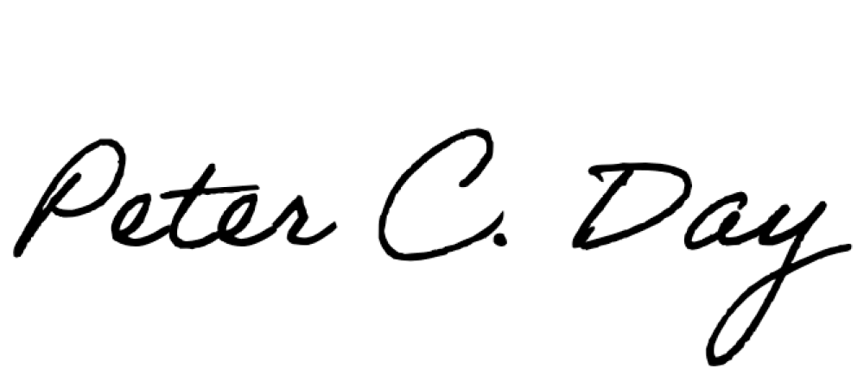**Grand West Estates Owners Association,** a Colorado nonprofit corporation

By: Its: President